Universal Support: Help to Claim Supervising Adviser
Job pack

Thanks for your interest in working at Citizens Advice North Somerset. This job pack should give you everything you need to know to apply for this role and what it means to work at Citizens Advice.

In this pack you’ll find:
- Our values
- 3 things you should know about us
- Overview of Citizens Advice and Citizens Advice North Somerset
- The role profile and personal specification

Want to chat about this role?
If you want to chat about the role further, you can contact Fiona Cope by emailing fiona.cope@nscab.org.uk or calling 01934 836202

Our values
We’re inventive. We’re not afraid of trying new things and learn by getting things wrong. We question every idea to make it better and we change when things aren’t working.
We’re generous. We work together, sharing knowledge and experience to solve problems. We tell it like it is and respect everyone.
We’re responsible. We do what we say we’ll do and keep our promises. We remember that we work for a charity and use our resources effectively.
3 things you should know about us

1. We’re local and we’re national. We are a local independent charity covering North Somerset and a member of the national Citizens Advice service. This a network of around 300 independent local Citizens Advice services across England and Wales.

2. We’re here for everyone. Our advice helps people solve problems and our advocacy helps fix problems in society. Whatever the problem, we won’t turn people away.

3. We’re listened to - and we make a difference. Our trusted brand and the quality of our research mean we make a real impact on behalf of the people who rely on us.

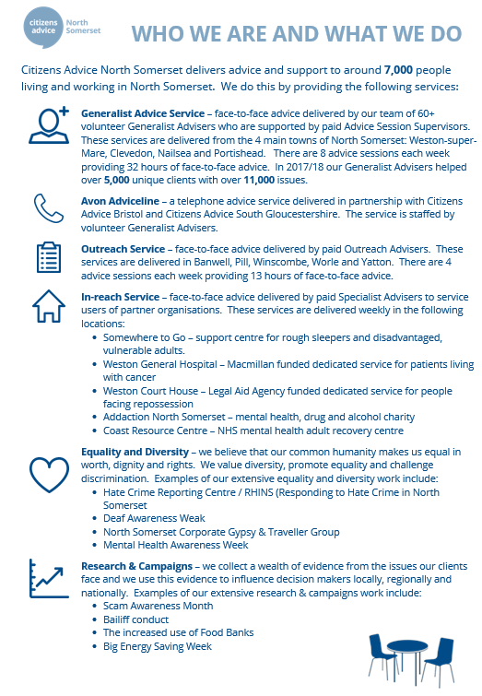
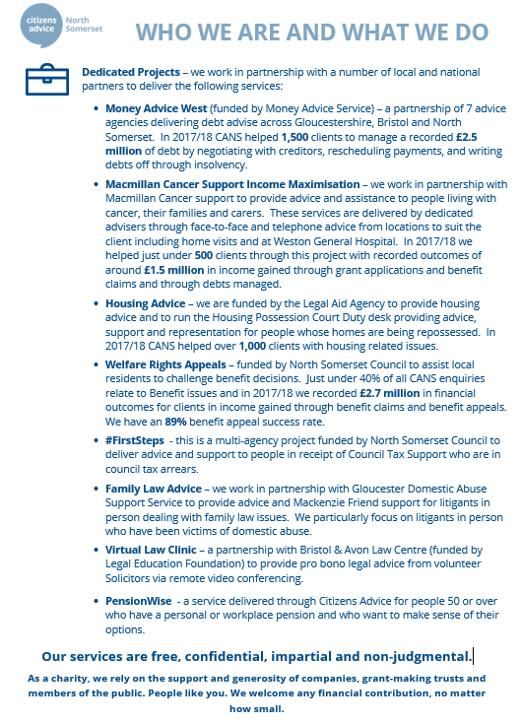

Overview of Citizens Advice

The Citizens Advice service is made up of Citizens Advice - the national charity - and a network of around 300 local Citizens Advice members.  This role sits within our network of independent charities, delivering services from  - over 600 local Citizens Advice outlets  - over 1,800 community centres, GPs’ surgeries and prisons  They do this with:  - 6,500 local staff  - over 23,000 trained volunteers  Our reach means 99% of people in England and Wales can access a local Citizens Advice within a 30 minute drive of where they live. | 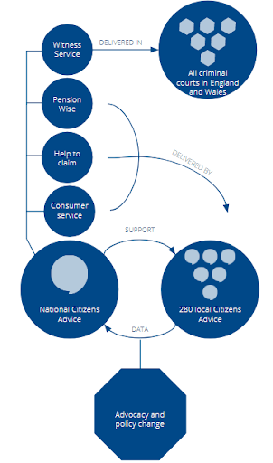

The role
Citizens Advice is set to deliver a new service called “Universal Support: Help to Claim” which offers end-to-end support to help people make a new Universal Credit claim and be ready for when their first payment arrives.
We are looking for a supervising adviser with good IT skills to support clients to make and complete their new Universal Credit claim, and supervise/mentor volunteer staff to supplement the service delivery.

You’ll have the ability to interview clients using sensitive listening and questioning skills to get to the root of the issues and empower clients, whilst maintaining structure and control of meetings.

You’ll have the ability and knowledge to monitor the case records / telephone calls / emails of designated staff to meet quality standards and service level agreements.

Role profile
Advice giving

Interview clients using sensitive listening and questioning skills in order to allow clients to explain their problem(s) and empower them to set their own priorities

Supporting clients to use IT to make their new Universal Credit claim

Use Citizens Advice resources to find, interpret and communicate the relevant information to clients

Complete benefits checks when appropriate

Research and explore options and implications so that clients can make informed decisions.

Act for the client where necessary using appropriate communication skills and channels.

Refer internally or to other specialist agencies as appropriate.

Ensure that all work meets quality standards and the requirements of the funder

Ensure that work reflects and supports the Citizens Advice service's equality and diversity strategy.

Maintain detailed case records for the purpose of continuity of casework, information retrieval, statistical monitoring and report preparation.

Work in a variety of settings including community outreach, Jobcentres and local authority offices as required

Complete the required training to comply with quality assurance processes

Research and campaigns

Support our research and campaigns work through various channels including case studies, data collection and client consent

Professional development

Keep up to date with legislation, policies and procedures and undertake appropriate training

Read relevant publications

Attend relevant internal and external meetings as agreed with the line manager

Prepare for and attend supervision sessions/team meetings/staff meetings as appropriate

Administration

Use of telephony and IT equipment for multichannel delivery of advice services

Use of IT software for statistical recording of information relating to research and campaigns and funding requirements, record keeping and document production. Ensure GDPR compliant training is completed on an annual basis

Ensure that all work conforms to our organisation’s systems and procedures

Maintain complaints procedures in accordance with Citizens Advice guidelines.

Keep up to date with policies and procedures relevant to our organisations work and undertake appropriate training.

Other duties and responsibilities

Assist and advise the relevant Team Leaders on compliance with Citizens Advice project requirements and advice quality standards.

Identify the training needs of staff through support and supervision and contribute towards the organisation’s training and development plan.

Carry out any other tasks that may be within the scope of the post to ensure the effective delivery and development of the service

Demonstrate commitment to the aims and policies of Citizens Advice

Abide by health and safety guidelines and share responsibility for own safety and that of colleagues

Person specification
Essential
1. At least two years recent and ongoing experience of generalist/benefit advice service delivery, including a thorough understanding of Universal Credit and the ability to meet Citizens Advice competence requirements (with appropriate training if necessary) for an advice session supervisor.
2. Ability to interview clients using sensitive listening and questioning skills to get to the root of the issues and empower clients, whilst maintaining structure and control of meetings with them.
3. Ability to give and receive feedback objectively and sensitively and a willingness to challenge constructively
4. Ability to supervise and mentor volunteers in all service delivery areas.
5. Ability to use telephony and IT systems to deliver services across multiple channels i.e. webchat and telephone
6. Good IT knowledge with an ability to support clients with their online claim application and to use IT systems and packages, and resources in the provision of advice, record keeping and document production.
7. Ability and willingness to work as part of a team and develop our volunteers
8. A commitment to continuous professional development, including a willingness to develop knowledge and skills in advice topics
9. Ability to travel to and work in outreach settings with an understanding of information assurance and safety in those settings
10. Ability to develop and maintain positive working relationships with external stakeholders
12. Ability to monitor and maintain quality standards for advice provision and quality assurance
13. A good up to date understanding of equality and diversity and its application to the provision of advice, and the supervision and development of staff.
14. Ability to commit to and work with the aims, principles and policies of the Citizens Advice service

In accordance with Citizens Advice national policy we will require the successful candidate to be screened by the DBS. However, a criminal record will not necessarily be a bar to your being able to take up the job.

